**Educational Guide**

*A*

*Mini Project-1*

*Submitted in partial fulfilment of the*

*Requirements for the award of the Degree of*

**BACHELOR OF ENGINEERING**

IN

**INFORMATION TECHNOLOGY**

BY

Venkata Sai Hemanth Kumar. V -1602-19-737-182

Komaraneni Veerendranath Chowdhari -1602-19-737-313

V. Kalyan -1602-19-737-135



**Department of Information Technology**

**Vasavi College of Engineering (Autonomous)**

**(Affiliated to Osmania University)**

**Ibrahim Bagh, Hyderabad-31**

**2020**

**Vasavi College of Engineering (Autonomous)**

**(Affiliated to Osmania University)**

**Hyderabad-500 031**

**Department of Information and technology**



**DECLARATION BY THE CANDIDATE**

We **Venkata Sai Hemanth kumar.V** , **Komaraneni Veerendranath Chowdhari** and **V. Kalyan,** bearing roll numbers

**1602-19-737-182** ,**1602-19-737-313 and 1602-19-737-135 herby** declare that the project report entitled **Educational Guide,** is submitted in partial fulfilment of the requirement for the award of the degree of **Bachelor of Engineering** in **Information Technology.**

This is a **record of Bonafide** work carried out by us and the results embodied in this project report has not been submitted to any other university or institute for the award of any other degree or diploma.

**AKNOWLEDGEMENTS**

Our Mini Project would not have been successful without the help of several people. We are extremely thankful to our college, Vasavi College of Engineering, for providing the opportunity to implement our project, “Educational guider”.

We would like to express our gratitude to Ms. Divya Lingineni, Assistant Professor, Department of Information Technology, Ms. Aruna, Professor, Department of Computer Science and Engineering, Vasavi College of Engineering, for their esteemed guidance, moral support and invaluable advice provided by them for the success of the Mini Project.

Sincerely,

Venkata Sai Hemanth kumar.v -1602-19-737-182

Komaraneni Veerendranath Chowdhari -1602-19-737-313

Kalyan.V-1602-19-737-135

**ABSTRACT**

“Educational guide” is a one-point destination for students who want to know about colleges, estimate the colleges which they can grasp, and also get details about the college.

Using our application, she/he can find the list of colleges based on their rank, type of exam and Location. additionally, we are providing basic information about colleges like placement details, fee structure etc.

**Index**

|  |  |  |
| --- | --- | --- |
| **S.no** | **Contents** | **Page no.** |
| 1) | Cover Sheet | 1 |
| 2) | Declaration | 2 |
| 3) | Acknowledgement | 3 |
| 4) | Abstract | 4 |
| 5) | Introduction | 6 |
| 6) | Technology | 7 |
| 7) | Proposed Work / Code | 8-44 |
| 8) | Result | 45-59 |
| 9) | Additional Knowledgegained | 60 |
| 10) | Conclusion and Future works | 61 |
| 11) | References | 62 |

**Introduction**

“Educational guide” is a one-point destination for students who want to know about colleges, estimate their colleges, and also get details about the college.

Using our application, she/he Can find the list of colleges based on their rank, type of exam and Location. additionally, we are providing basic information about colleges like placement details, fee structure etc.

The software uses a SQL database as backend for storage and retrieving data which is going to be manuplated and java enhanced GUI for the better user interaction.

**List of Features**

1. **Registration / Login**- First step a user takes in this program should either login or register. If the user wishes to register, he needs to provide a proper username and password of his wish (The password stays hidden). In case of login the user needs to give the registered and the password then if he passes this session, he gets to the page of template selection or the program terminates.
2. **Estimate College** – The user is required to provide us with his rank and his stream of exam (Here we consider only 1 case of Examination) and using the existing data in the database the software displays a list of colleges into which he can opt even specifically decreeing the branch which he can get into based on his rank and caste.
3. **Get College Location** - The user is required to give the College Id (Unique Id given to each college known to the public) based on it the College location stored in the database is retrieved and displayed as a table.
4. **Get College Placement-** The user is required to give the College Id (Unique Id given to each college known to the public) based on it the College Placement details with respect to each branch, stored in the database is retrieved and displayed as a table
5. **Get College Specs**- The user is required to give the College Id (Unique Id given to each college known to the public) based on it the College Specification details with respect to store in the database is retrieved and displayed as a table

**Technology**

**Software used-**

1. **Eclipse IDE for Java Developers - 2020-09** -Eclipse IDE provides an easy and better environment for working with java program. It provides suggestion and error detection which provides an overall easier experience.
2. **MySQL Workbench-** This MySQL workbench provides an easy environment to setup, link and create databases.
3. **Windows OS(Version-10) -** Windows 10 was used to install and run the above applications and this program.

**Hardware used-**

1. **Laptop/PC**- No extra special external devices were used for this project, a standard laptop loaded with Windows OS software was used.

**Proposed Work**

**Design**

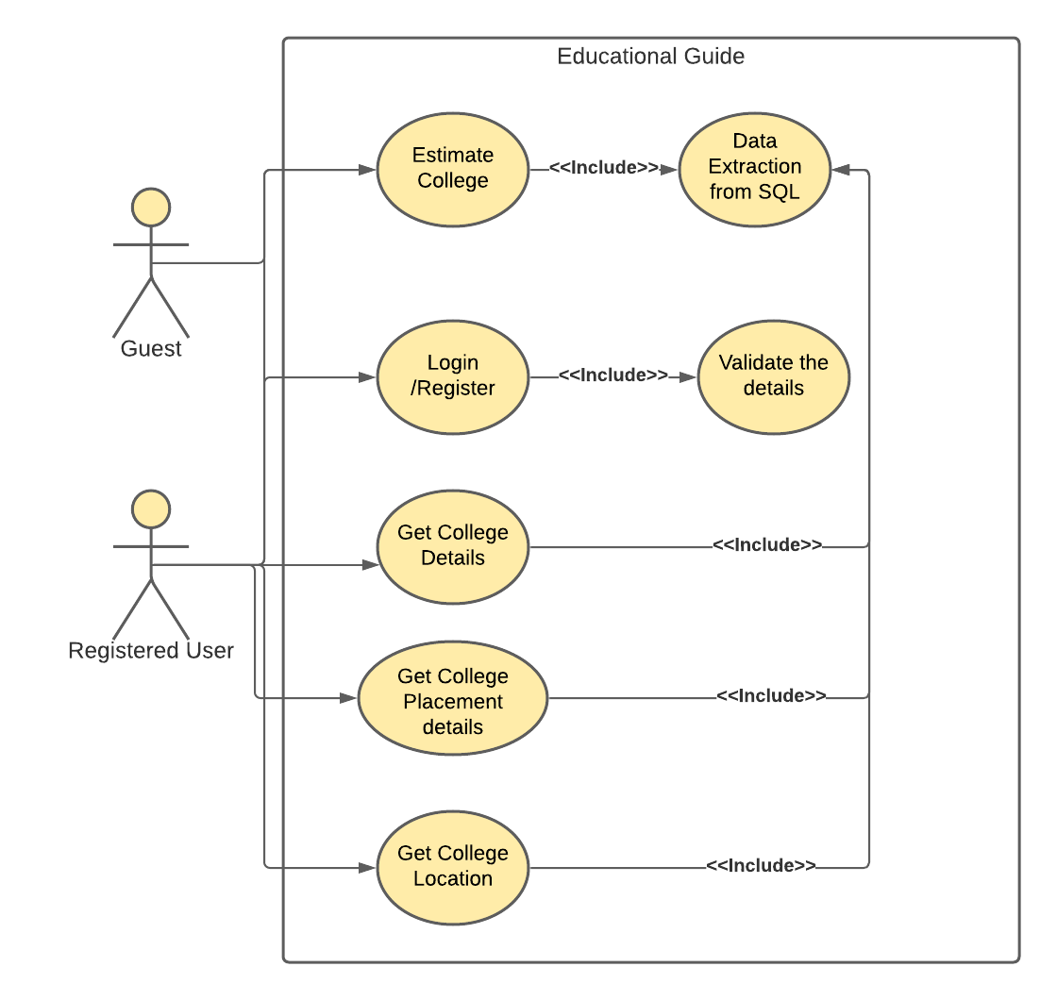

The above Design diagram shows the working of the entire program and the most basic types of modules/use cases provided-

1. **Registration / Login**- First step a user takes in this program should either login or register. If the user wishes to register, he needs to provide a proper username and password of his wish (The password stays hidden). In case of login the user needs to give the registered and the password then if he passes this session, he gets to the page of template selection or the program terminates.
2. **Estimate College** – The user is required to provide us with his rank and his stream of exam (Here we consider only 1 case of Examination) and using the existing data in the database the software displays a list of colleges into which he can opt even specifically decreeing the branch which he can get into based on his rank and caste.
3. **Get College Location** - The user is required to give the College Id (Unique Id given to each college known to the public) based on it the College location stored in the database is retrieved and displayed as a table.
4. **Get College Placement-** The user is required to give the College Id (Unique Id given to each college known to the public) based on it the College Placement details with respect to each branch, stored in the database is retrieved and displayed as a table
5. **Get College Specs**- The user is required to give the College Id (Unique Id given to each college known to the public) based on it the College Specification details with respect to store in the database is retrieved and displayed as a table

**Results (Screen shots of outputs)**

**Home Page**

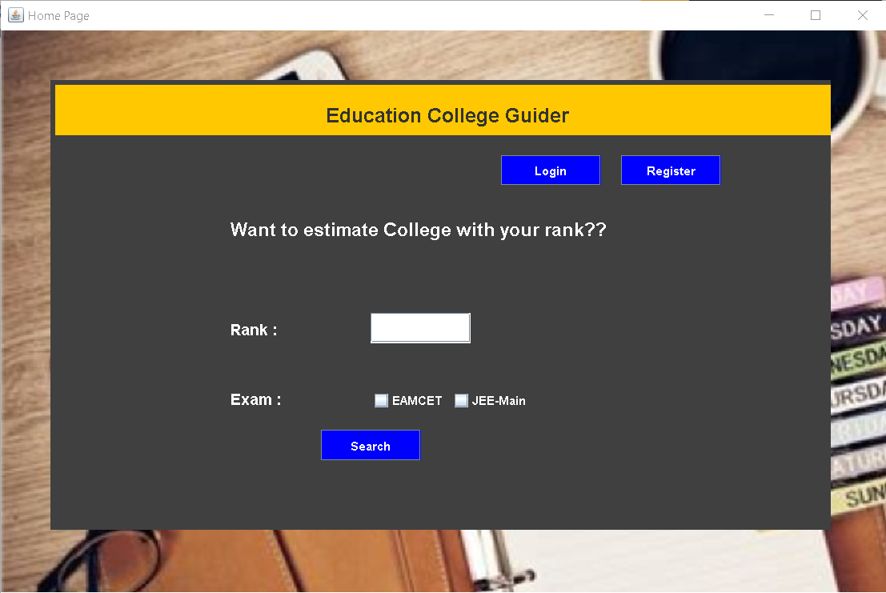

**Home Page with valid guest user inputs**

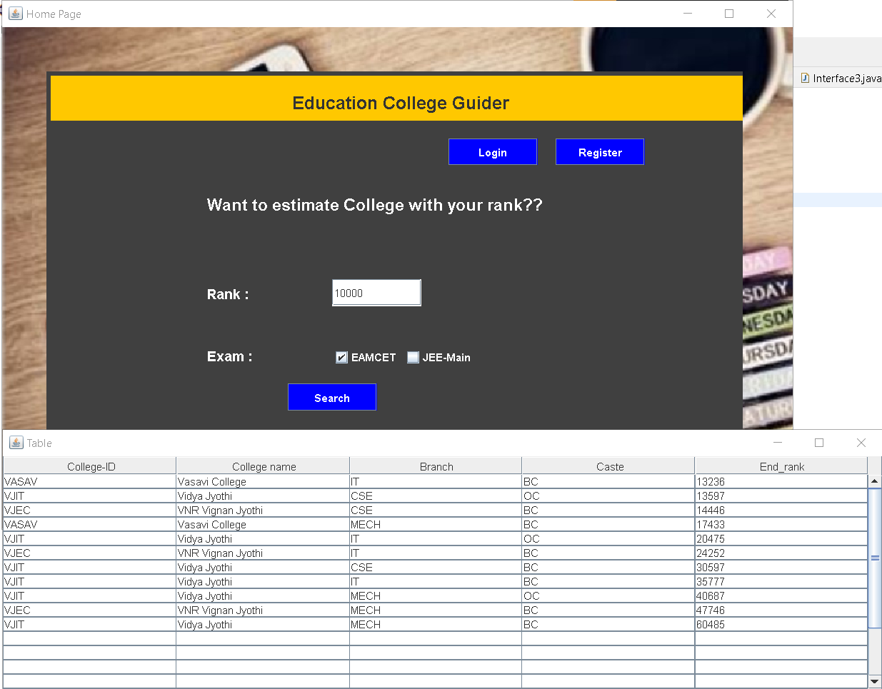

**Home Page with invalid guest user inputs**

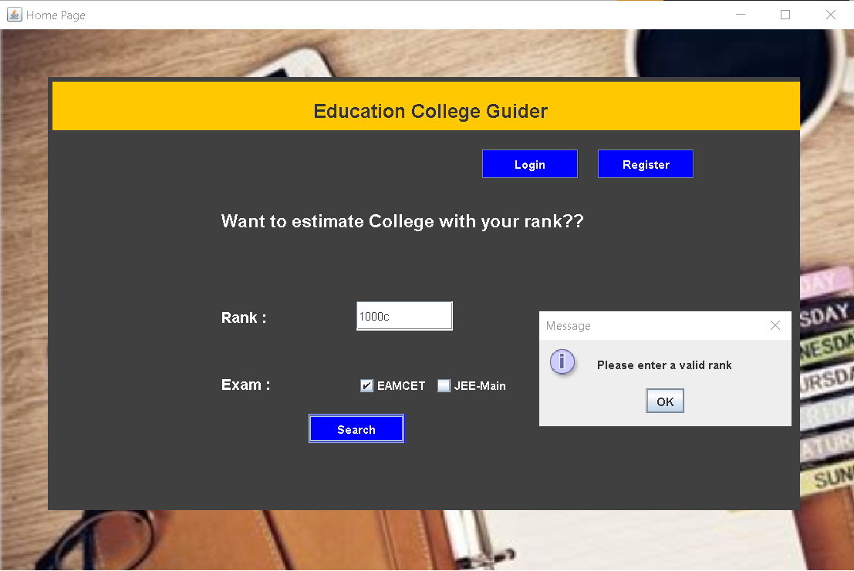

**Login Page**

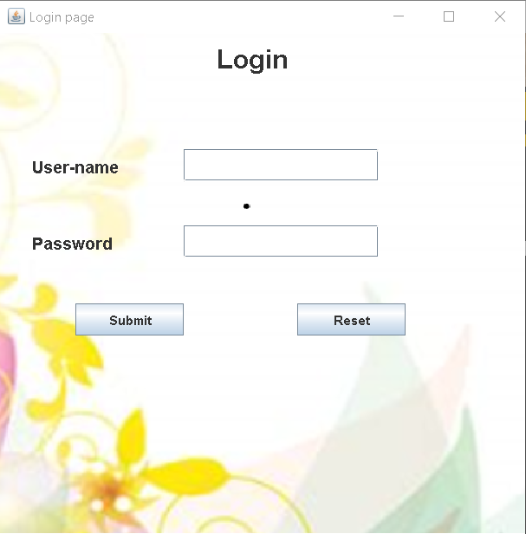

**Login Page with valid details**

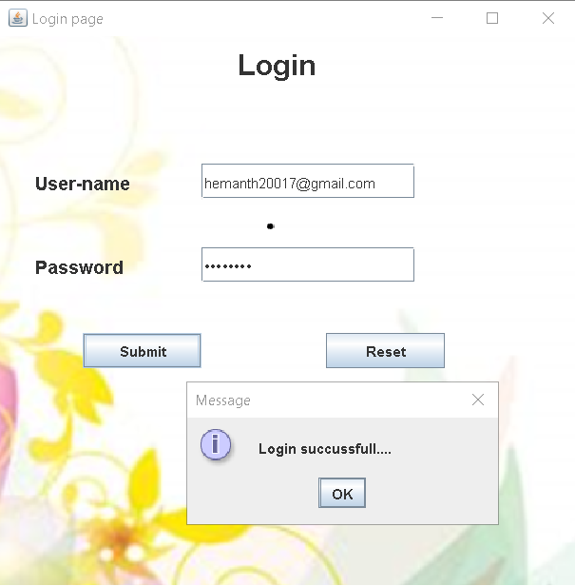

**Login Page with invalid input details**

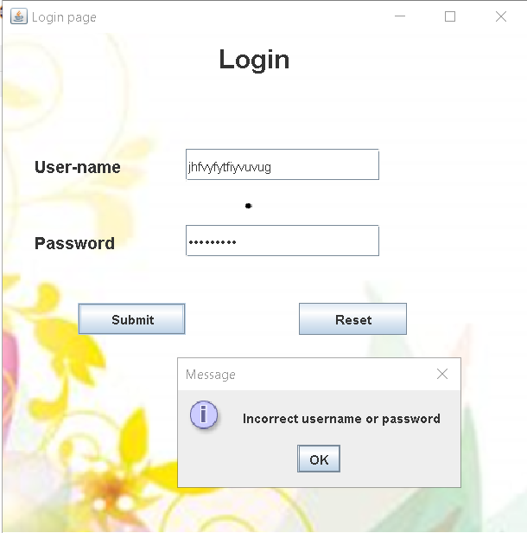

**Register Page**

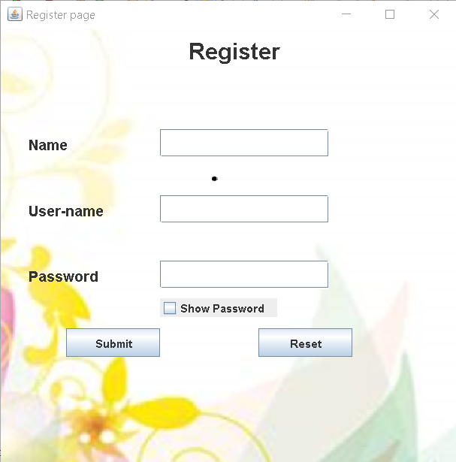

**Register Page with already existing User- ID and details**

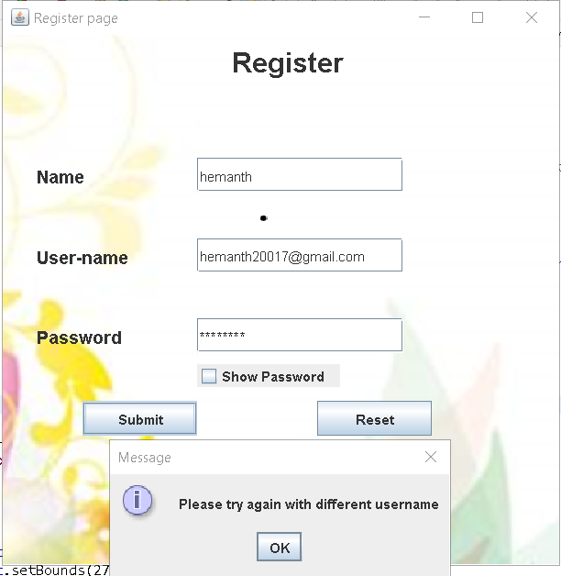

**Register Page with valid details**

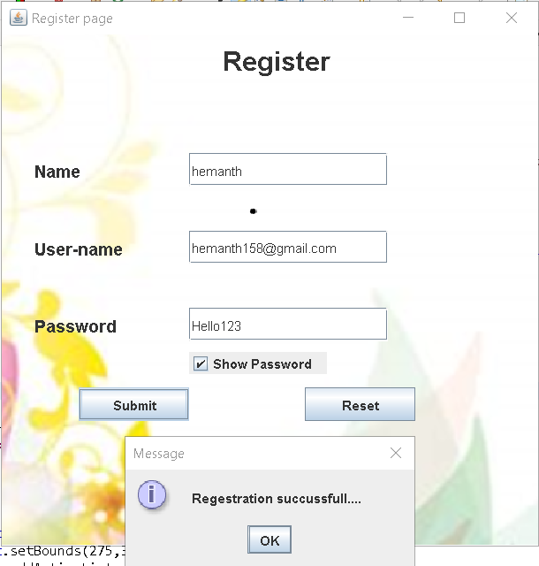

**Follow up Main Service Page**

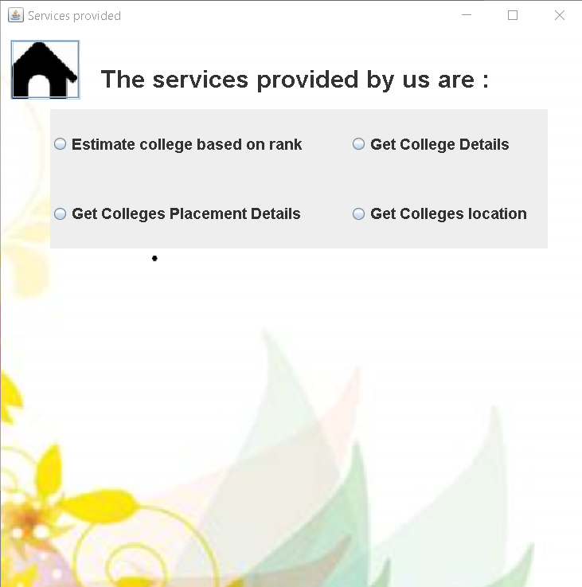

**Main Service page with option invoked**

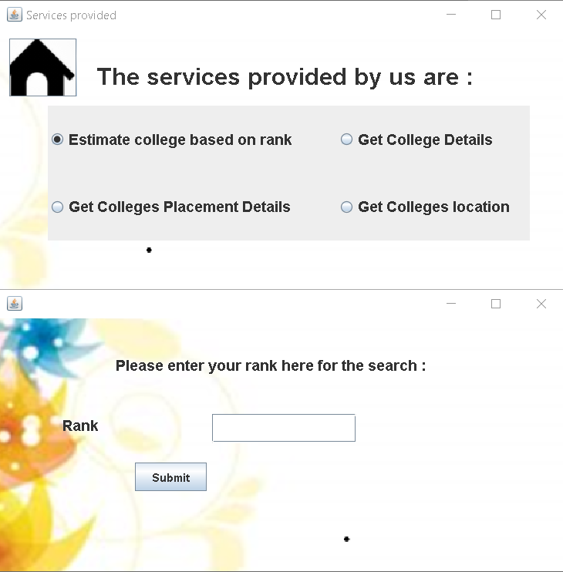

**Main page dealing with invalid inputs**

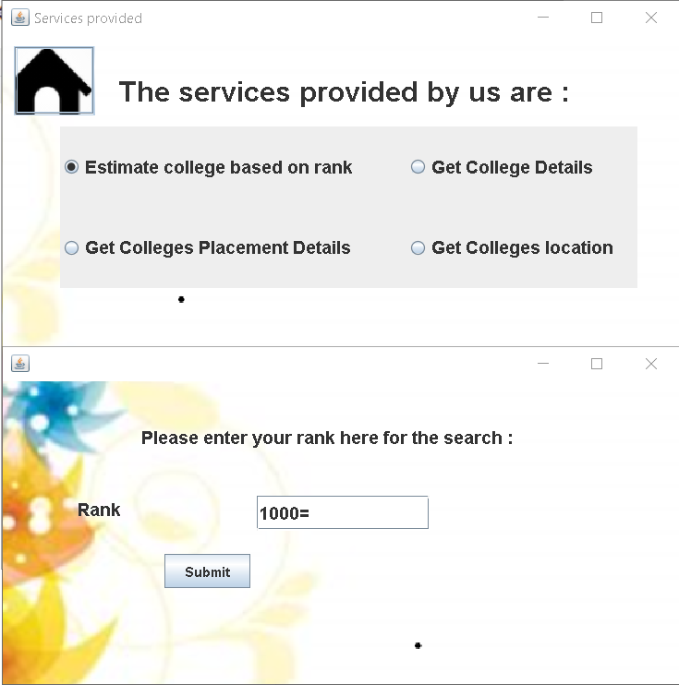

After hitting submit

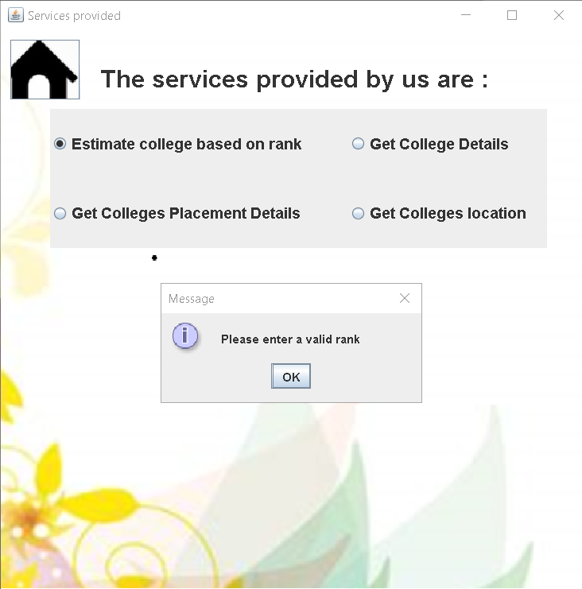

**College Estimation with Valid input**

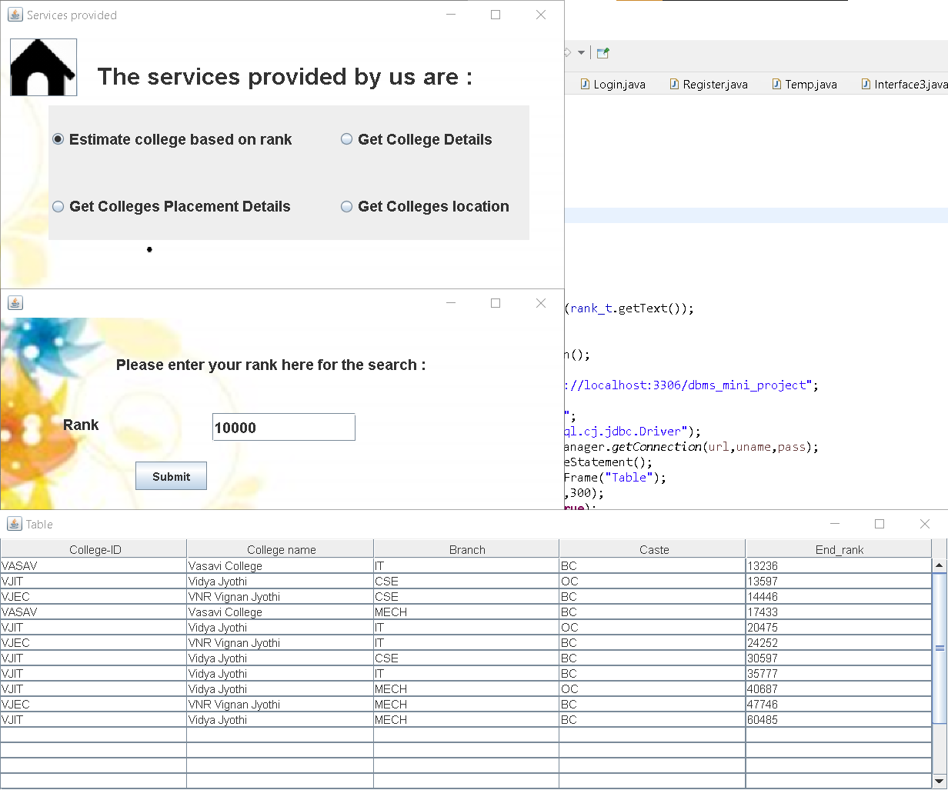

**Get College details**

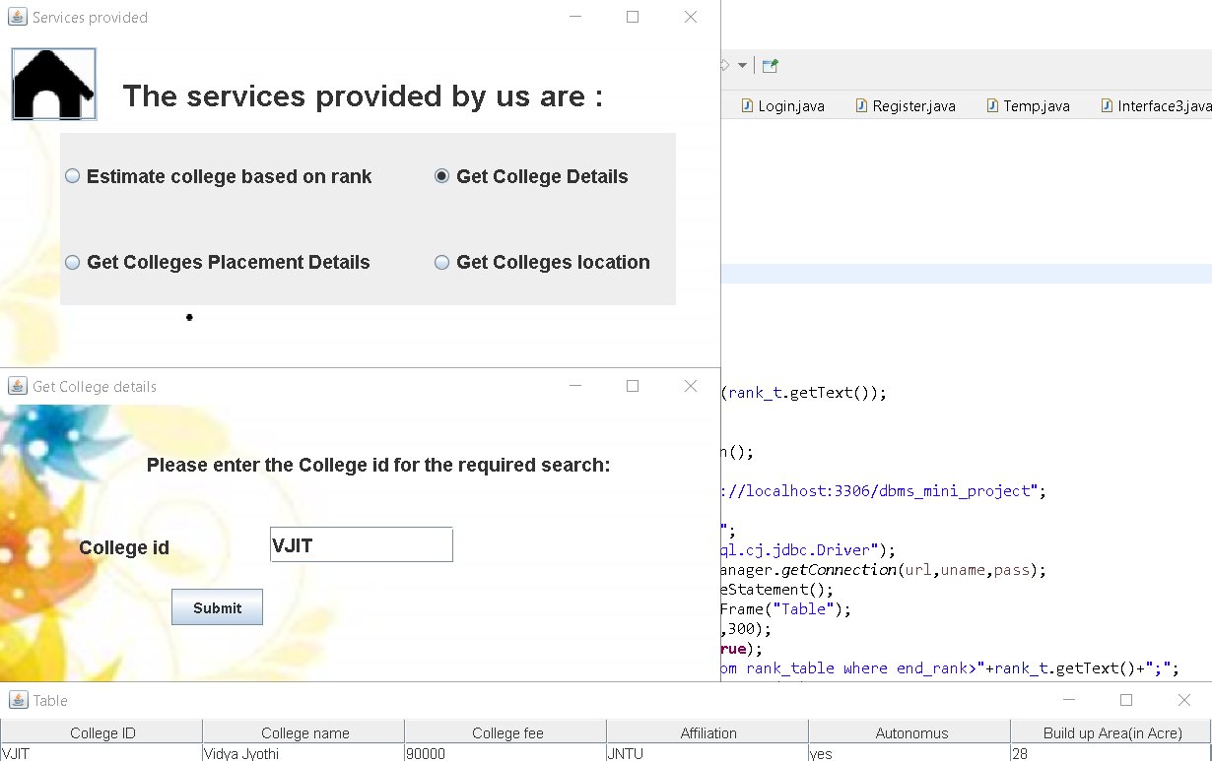

Get College Placement details

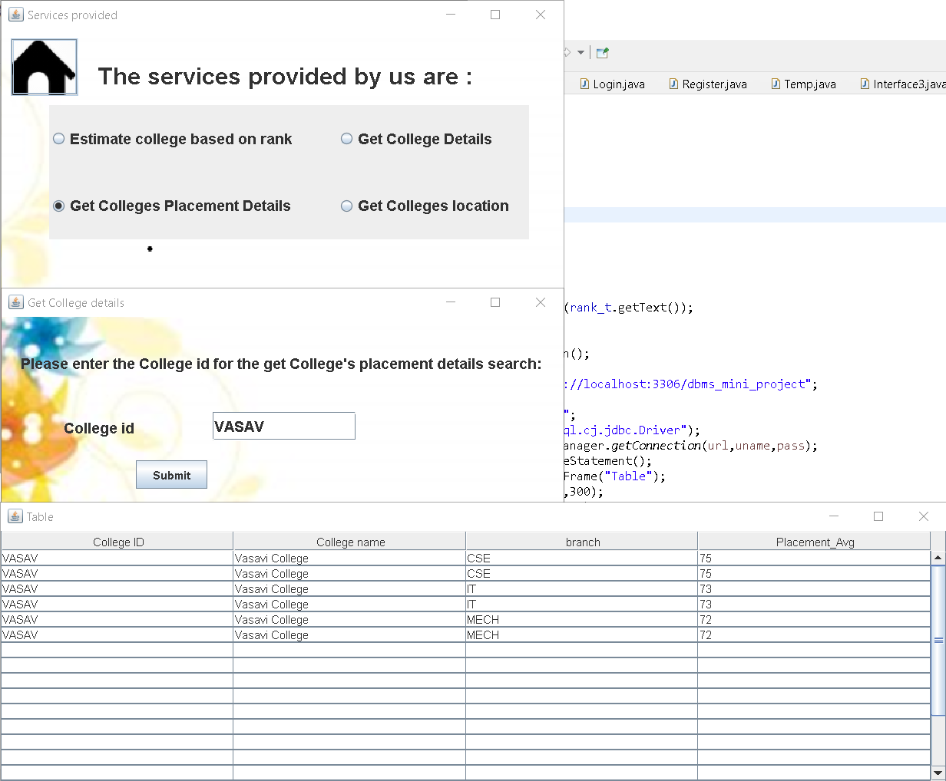

Get College Location

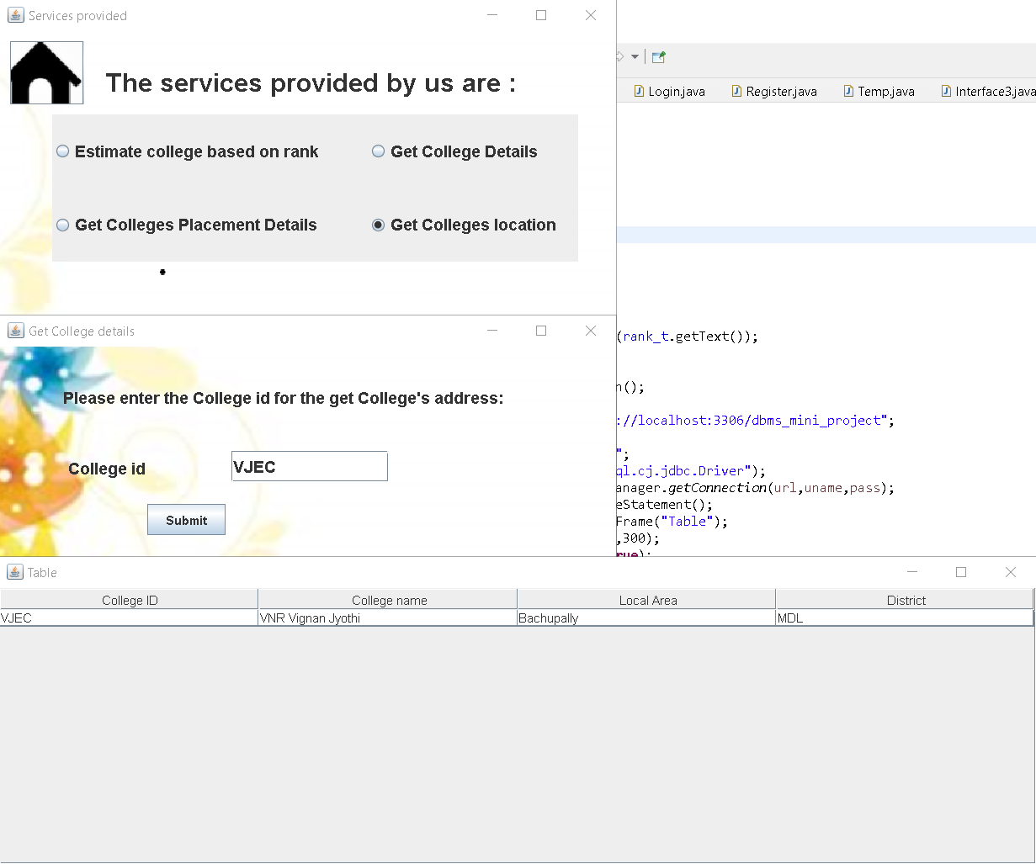

**Tables used in the project**

Table-1 (User_login_details)

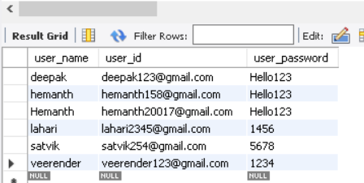

Table-2(College data)

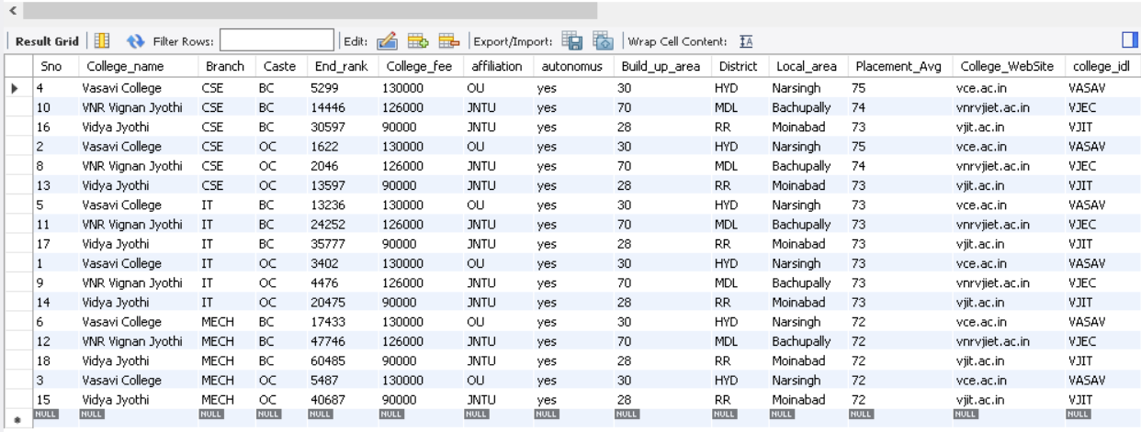

View–1 (Rank table)

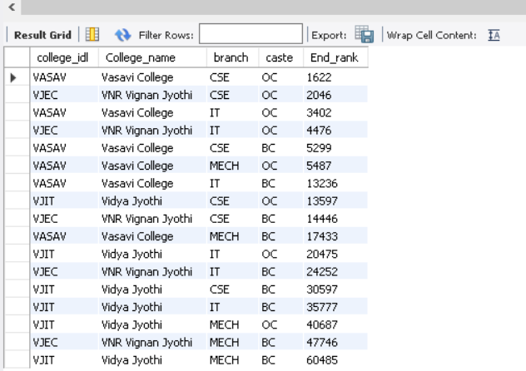

View-2(College details)

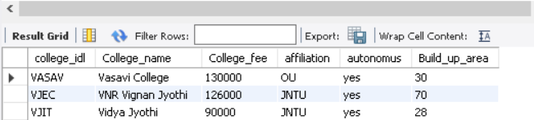

View-3(college Placement)

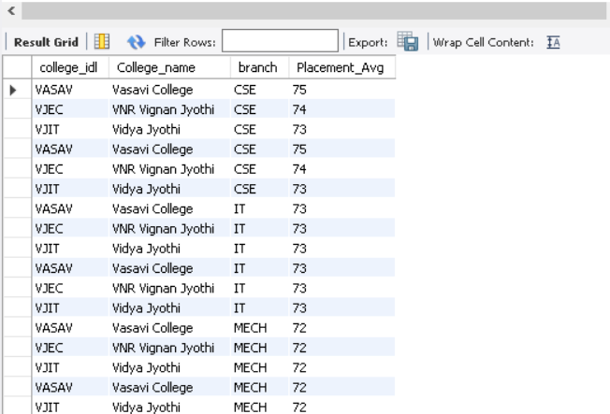

View-4(College Address Details)

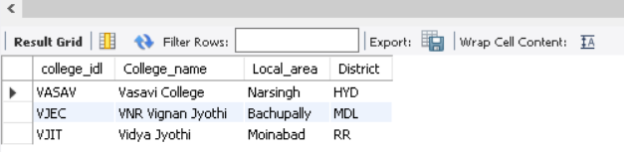

**Knowledge acquired and implemented in this program**

* + The usage and handling the java programs, syntax and implementation in a real time project.
  + Use of Image Icons as Background and Button in Java Swing.
  + We have MySQL as a backend support for the software. So we learned DBMS implementation and how to connect the java programs with the SQL tables and views.
  + Usage of tables in the JSwing GUI .
  + Establishing a connection between a java program and a database.

**Conclusion and Future Scope**

* This software is build using java Swing and provides better interface with the help of a GUI interface. So we wish to improve the experience by developing it as web-based solution.
* At present we just incorporated only EAMCET exam based data.in the future we wish to increase the mode of examinations to other type of examination.
* The solution provides only the basic services mentioned in the SRS bu twe can improve the software specialization in searching and retrieving the data according to user command.
* Improve the existing Exception handling system put in the present deleveribilty.

**References**

* [**https://www.programiz.com**](https://www.programiz.com)
* [**https://www.sanfoundry.com/**](https://www.sanfoundry.com/)
* [**https://stackoverflow.com/**](https://stackoverflow.com/)
* [**https://www.codeproject.com/Questions/94511/Run-Notepad-with-help-of-C-program**](https://www.codeproject.com/Questions/94511/Run-Notepad-with-help-of-C-program)
* **Youtube lectures**